**ASSIGNMENT-10.2**

**NAME: PRANAVI P**

**ROLL:2403A51328**

**BATCH:13**

**TASK-1:**

* Write python program as shown below.
* Use an AI assistant to review and suggest corrections.

**CORRECTED CODE:**

**Observation:**

* The function correctly calculates the factorial of the input number n.
* The loop iterates from 1 up to and including n.
* The main function demonstrates how to use calcFact and prints the result.

The code includes an if condition that checks if the calculated factorial is greater than 100

**TASK-2:**

* Write the Python code for Fibonacci as shown below and execute.
* Ask AI to improve variable names, add comments, and apply PEP8 formatting (cleaned up).

Students evaluate which suggestions improve readability most. One

**CORRECTED CODE:**

Improving variable names: Using descriptive names like generate_fibonacci_series instead of f1, limit instead of xX, and fib_series instead of Zz makes it clear what each part of the code represents.

Adding comments: Comments explain the purpose of different sections of the code and clarify any non-obvious logic. This helps someone reading the code quickly grasp what's happening.

Applying PEP8 formatting: PEP8 is a style guide for Python code. Following it consistently (like using consistent indentation and spacing) makes the code visually cleaner and easier to scan, reducing cognitive load.

**TASK-3:**

* Write a Python script with 3–4 functions (e.g., calculator: add, subtract, multiply, divide).
* Incorporate manual docstring in code with NumPy Style
* Use AI assistance to generate a module-level docstring + individual function docstrings.
* Compare the AI-generated docstring with your manually written one**.**

**Manual code:**

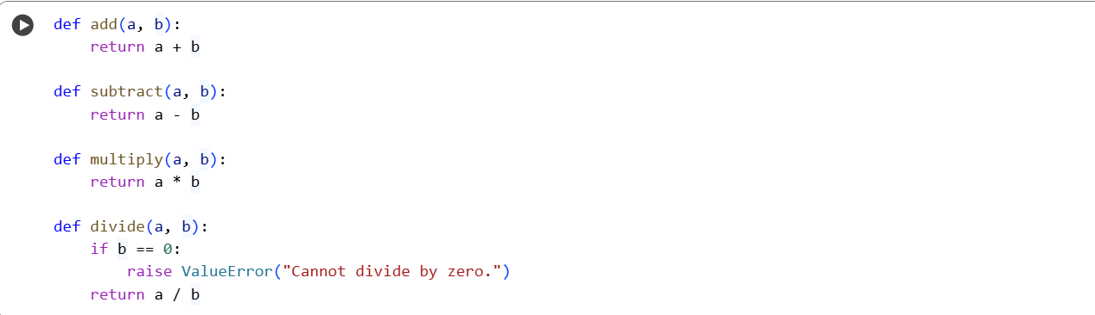

**Ai generated:**

**Comparision of both the codes:**

| Feature | User's Code Docstrings | Generated Code Docstrings |
| --- | --- | --- |
| Module Docstring | Missing | Present, describes module purpose |
| Function Docstrings | Present but incomplete (e.g., multiply, divide) | Present and complete (purpose, params, returns, raises) |
| Formatting | Inconsistent | Consistent (NumPy style) |
| Readability | Lower | Higher |
| Usability | Lower | Higher |